SAMPLE CHURCH COVENANT

Having been led, as we believe by the Spirit of God, to receive the Lord Jesus Christ as our Savior and, on the profession of our faith, having been baptized in the name of the Father, and of the Son, and of the Holy Spirit, we do now, in the presence of God and this assembly, most solemnly and joyfully enter into covenant with one another as one body in Christ.
We engage, therefore, by the aid of the Holy Spirit to walk together in Christian love; to strive for the advancement of this church in knowledge, holiness, and comfort; to promote its prosperity and spirituality; to sustain its worship, ordinances, discipline, and doctrines; to contribute cheerfully and regularly to the support of the ministry, the expenses of the church, the relief of the poor, and the spread of the gospel through all nations.
We also engage to maintain family and secret devotions; to religiously educate our children; to seek the salvation of our kindred and acquaintances; to walk circumspectly in the world; to be just in our dealings, faithful in our engagements, and exemplary in our deportment; to avoid all tattling, backbiting, and excessive anger; to abstain from the sale of, and use of, destructive drugs or intoxicating drinks as a beverage; to shun pornography; to be zealous in our efforts to advance the kingdom of our Savior.
We further engage to watch over one another in brotherly love; to remember one another in prayer; to aid one another in sickness and distress; to cultivate Christian sympathy in feeling and Christian courtesy in speech; to be slow to take offense, but always ready for reconciliation and mindful of the rules of our Savior to secure it without delay.
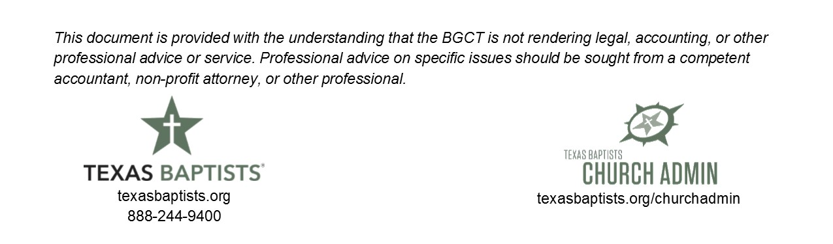
We moreover engage that when we remove from this place we will, as soon as possible, unite with some other church where we can carry out the spirit of this covenant and the principles of God’s Word.

